Karibu Kenya
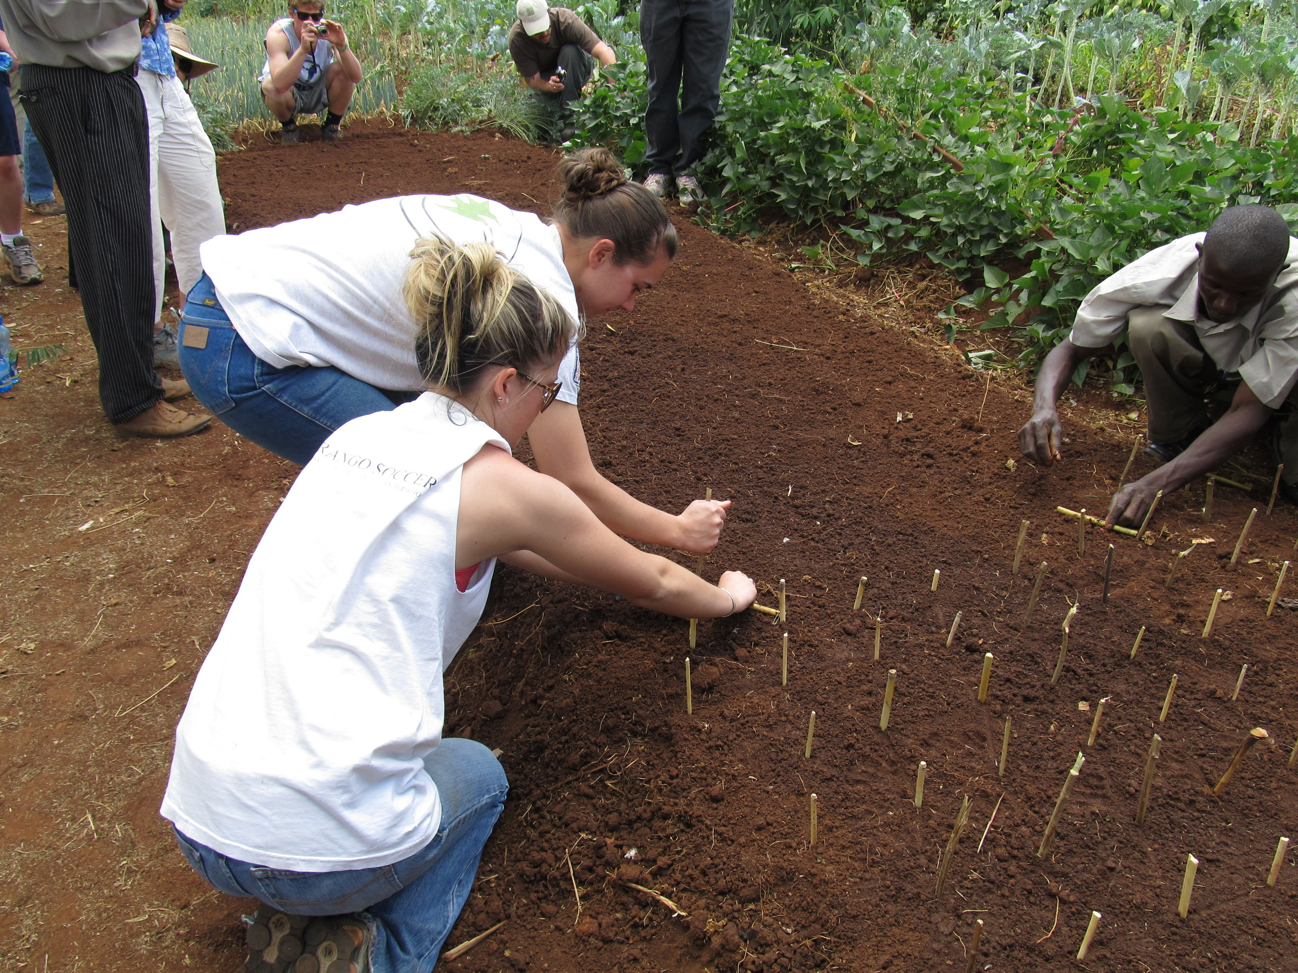
By: Emily Wotkyns
March 1, 2011

Introduction
The thought of study in a foreign country as an Undergraduate was not something that I expected to have the opportunity to participate in. I could not have been more excited to expand my educational experiences around the globe. Studying abroad in Kenya allowed me to evaluate and analyze the differences in Agriculture and culture around the world. There is no better way to understand differences in practices and techniques than experiencing the successes and challenges of these practices in both developed and developing countries first hand. Resources and management strategies vary in all locations across earth. Depending on the presence and availability of resources in varying locations the definition of sustainable practices can be very different. This educational traveling experience has assisted me in my completing my academic career by broadening and expanding my knowledge base of Sustainable agricultural practices. As we are continually told, “youth are the future of agriculture”, so what better way could there be to educate our youth than supporting and encouraging the expansion their agricultural knowledge to global levels.
Expanding my knowledge to global levels was one of the most rewarding experiences I have encountered thus far in my academic career. Visiting a variety of operations in Kenya I was not only able to see the differences in agricultural practices but also the drastic differences in social and cultural structures and interactions.
Initial Impressions
Following the long and tiring hours of traveling I was glad to know that my feet would be staying on solid ground for more than just a few hours. As we stepped off the plane the experience began, the humidity was the first thing that I noticed significant difference in. After scooting through customs and sorting out all the lost baggage it was so nice to know we were going where there would be a bed. Before leaving on this adventure I had assumptions about what I was going to encounter along the trip. Driving to Eshell Gardens the night we arrived was kind of a misleading experience for me. Being the middle of the night as we were driving, my ability to become acquainted with my surroundings was distorted. From the looks of all the lights and buildings on the drive I felt like Nairobi was fairly modern and well kept city. It wasn’t till the next morning the reality that I was actually in a third world country set in. Driving through town I was shocked to see all the people on the streets and all the undeveloped roads and roadsides. Along with being shocked at the underdevelopment, another thing that caught my attention not just at the beginning of the trip, but the entire time was the way the Kenyan citizens dressed. Even though majority of the citizens walk everywhere along the dirt roadsides in the mud and among animals and mounds of trash, their clothing was very dressy, rarely did you see gentlemen in anything other than slacks and button up shirts and dress shoes, and the women nearly always wore dresses and heels. I was very taken back seeing these communal differences, and I was very excited to continue the journey and encounter more new and exciting experiences.
Impressions of City life in Kenya
Having a few days in Nairobi once we arrived couldn’t have been a better idea. I myself am far from a city girl, traveling to Denver and even Cheyenne or Casper is quite the experience for me. Spending time in the city is like a whole vacation in itself for this country girl. Knowing that Nairobi was one of the largest most populated areas in Kenya I was intimidated knowing we would be spending so a pretty large chunk of a time moving around the city and mingling in close proximity with the natives. I went into this experience with the expectation of feeling out of place and like a foreigner, but I guess the actual experience was much more dramatic than I expected it to be. The experience that I was continually comparing to being in a foreign country was my travels to Mexico, but I was just dumb founded at some of the reactions we received form the locals. I was forced to be continually aware of all my surroundings in every direction. I felt like we all had to work together as a team and be present as a whole, as not to get taken advantage of as outlying individuals. Observing my surroundings as we moved across the city was very interesting. I was astounded by the amount of trash that there was across the entire city. I don’t think that the fact that there was trash all along the roadsides and in the markets that was so shocking to me, but more so the fact that there was so many people just hanging around the streets and markets giving off the impression they didn’t have anything to keep them busy. I figured that if every person sitting around pitched a little time and effort the city could be a far cleaner and less run down. This is one area where I feel cultural differences separate developed and developing countries. The city experience was a bonus experience for this adventure, but the agricultural experience was what I was most excited for.
Boys Prison
The first trip out of the city, we were all a little bit unsure of our destination. It was a very interesting to start traveling across the city and observe the changes in our structures and surroundings. I was very anxious, and so curious about getting into a more agricultural setting to see all the differences in respect to what I have grown up with. The feeling that we were going out into the more rural and agricultural communities, was very stimulating.
Reaching our destination was a relief, right up until the point I read the words on the gate we pulled up to. “Prison Services of Kenya,” talk about getting a little bit nervous. As we pulled in and I was really curious as to how this visit was going to be related to agriculture or plant sciences? Our guides explanation helped me to understand why this was a valid stop. The portion of the prison that we were going to be getting a tour of was a location for young males from the ages of 17-21. This location was an inmate facility, but the facility used a skills program which took these young boys who have committed crimes anywhere from stealing a pineapple in the market to more punishable extreme crimes. The idea behind the programs being implemented at this facility is that these young boys have been involved and engaged in criminal activity because the haven’t been taught the skills and trades to be productive and successful members of society. This prison location takes in young boys and for four months they are taught different trades which will allow them the ability to make a living and be successful in the corrupt societies which they have been brought up in. I found this visit to be very different form anything you could expect in the United States. We first visited the boys at the facility who had chosen to learn about the trade of farming. This was our first international agricultural encounter. The land and resources in Kenya are less abundant and plentiful so they use different practices to compensate for the limitations. I found that the practices they use help to ensure sustainability of the land and allow them to maximize production while being sure their land stays as viable as possible. Having the prisoners themselves talk to us and explain the concepts was a rewarding experience. I felt like I was able to learn a lot from them and relate with them since they were close in age with all of us. It was very interesting to compare the types of punishments they receive for their crimes in Kenya and how the same crimes could be punishable in the United States for offenders of the same age. Although the experience did make me the slightest bit uneasy, especially after my wardrobe mishap, I found the prisoners and staff folk to be very warm and inviting. One experience I can say they provided me with was the chance to sing Christmas carols in a foreign country while it was nearly 80 degrees outside and the middle of summer. This is an experience we were all so lucky to have encountered and I wouldn’t change or exchange it for anything else.
Finlays and Ketepa Tea Factories
Well lets just start by saying that my appreciation for tea just flew through the roof. I have never had the privilege of witnessing a crop in the field go through every step and process it takes in making a final product ready for the consumer. Before this trip I was not knowledgeable of tea in a way shape or form. Following our visits to the two factories and seeing all the processes involved in taking a tea leaf directly from the field and transforming it into a consumable and marketable product gave me a greater understanding about not just tea but the amount of labor and time which is invested in any consumer product.
A few things about the tea plantations and factories which stood out to me the most were the rate at which they were able to produce tea and the harvesting methods used, the way each sack of tea is tasted before being packaged, the machines used in the packaging process and finally the ability of the factories to do personalized packaging and shipping.
The tea plantations are so large and run for miles and miles across rolling hills, and in majority of the fields you can see native worker hand picking the ripe tea leaves. This was a step back in history, or so it seemed. But in reality this is the way they still do it, real culture shock for me. At this point in the trip I had become accustomed to the third world run down city way of life, but the agricultural experience of the trip was starting to set in. Hard manual labor is a reality here in Kenya and is not uncommon either. Although most of the harvesting of the raw material was done by hand it was neat to see that there are some mechanical advancements being implemented in practices. I found it interesting that the mechanical methods of harvesting are used less in Kenya than the manual methods. This was a contrast for me to the United States because anymore you are seeing increased mechanical methods and very few manual methods. I am curious to know if and when a switch in methods may occur in Kenya and how those switches could help or hinder production.
When we were touring the Ketepa factory and we got to watch the tasting the new tea coming to the factory I was amazed not only by the fact the every bag that came to the factory was hand sorted into grades and tasted, but even more so the talent if you will of the tasters. I can’t remember the number of tea’s that our guide mentioned each taster can taste at any given time, but I sure remember my jaw hurting thinking about it. Another thing that I found fascinating at the tea factory was the diversity in technology and packaging methods across the factory. Here we are at a factory in the middle of a poverty stricken part of Africa, yet the factory is using million dollar machines to package tea. As if the packaging of the tea by million dollar machines didn’t mix up my mind, as we went through the factory and observed some of the following processes we witnessed African women hand ironing cellophane wrappings on the outside of the final packaged products. I was so interested in the variety of modern and old fashioned technologies that were used in creating the final product. The final part of our tours which stood out to me was how the factory was able to customize packages to be shipped to different countries and vary the languages printed in the boxes to complement where it was to be shipped.
Agricultural Practices in Kenya
Agriculture in Kenya is nearly the exact opposite from what is practiced in the United States. Most all operations in Kenya, which we were exposed to with the exception of the tea factories, are small scale operations and tend to produce on a community level. These operations strive to practice sustainable methods by composting excess standing plant matter and also strategically using animal waste to create natural and nutrient rich fertilizers. The way that gardens and sites of agricultural production are set up in Kenya are very different form here in the United States as well.
The agricultural sites which we had the privilege of visiting in Kenya demonstrated a series of unique characteristics that made then significantly different from production you predominantly see in the United States The operations in Kenya were for the most part all small scale operations not getting bigger than a community based garden that worked to provide a variety nutrient rich crops to sufficiently support themselves. These operations strived and emphasized the importance of being sure you were able to provide for yourselves a well balanced diet and not specializing in any one particular area of production. Where in comparison the kind of production general observed in the United States is large scale commercial operations which are striving to specialize in only one or two crops. Though there is trading among families and communities on Kenya the extent of this trading is limited. Trading in the United States is the sole way that Americans even have the ability to survive, being sustainable and self sufficient are not emphasized nearly as strongly in our practices. Many citizens of Kenya pride their time on spending time in the garden producing for their families and there well being where in contrast American citizens pride their time in corporate office jobs and rely on grocery stores and income to provide for their families.
Another significant difference I observed in agricultural practices was sustainability. In the United States there has recently been increased amounts of talk concerning sustainability of agricultural practices and the environmental impacts of agriculture. Americans tend to emphasize that they are beginning to implement and use sustainable practices. I had really believed that this was true before visiting Kenya, and still do to some extent, but wonder if there are different definitions of sustainability in each place. Producers in the United States have begun using technologies like precision farming to decrease their inputs and impacts on natural resources, where as the Kenyans deem sustainable more as recycling natural inputs form households to creates increased productivity as a sustainable practices. A few of the reoccurring concepts of sustainability I saw being practiced in Kenya which I felt Americans can benefit from considering were the use animal waste in making liquid manure to apply to their crops. American producers don’t usually use natural fertilizers to stimulate crop growth, but more commonly use chemical fertilizers which are in general less sustainable.
Land resources in Kenya are far different form much of what is found here in the states and therefore the resources need to be managed differently form one another. I did take great interest in one of the concepts many of the producers chose to implement on their operations in the hopes of maximizing the use of the land they had available. This concept was the use of what was referred to as a fifty bed unit. I found this to be a very clever and scientifically rounded concept which allowed the producers to better reach productions goals for a variety of inputs.
As a result of evaluating and comparing practices used in Kenya and those used in the United States, I feel that agricultural practices around the world have loads that they can learn from evaluating practices used globally. I feel that overall American producers have loads they can learn form Kenyan producers and in turn the Kenyans have many things they could learn from us as well.
Conclusions
Traveling to a developing country and experiencing both cultural and agricultural differences has been a very rewarding and eye opening experience. I feel that the experience has helped me further my academic career and broaden my knowledge base of agricultural practices and social structures around the world. This experience is an experience I would encourage any individual to engage in should they have the chance. In my opinion , having a true understanding of agricultural practices in the United States means having the ability to understand and compare to agricultural practices around the world.

